International Symposium on Sediment Disasters under the Influence of Climate Change and Tectonic Activity (3rd): a sample for abstract

Sample subtitle (Not compulsory)

Tomomi Marutani¹, Masaharu Fujita²

In completion of a sample document, the following guidelines briefly illustrate the definite design of abstract for the 2nd International Symposium on Sediment Disasters under the Influence of Climate Change and Tectonic Activity.

General requirements for the definite abstract

In order to manage standardized appearance and structure of the accepted abstract for the symposium, the editorial board strictly demands to follow the instructions below:
1. Number of pages: The extended abstract must cover 2 pages (at least 1½ but strictly not more than 2 pages). This can for example easily be achieved by varying the size of an embedded illustration.
2. Illustrations must be in black and white only (strictly not colored).
3. The abstract must be written in English.

PAGE LAYOUT

4. Page format: DIN A4, no page numbering!
5. Side margins for all pages: 25mm above, below, left and right
6. One column per page
7. Title, subtitle as well as names of the author(s) must be set in the center
8. The main text must be set in a grouped style.
9. The layout of the first page:

Title: Spacing of 3 lines above the title line (single line spacing) or altogether 4 cm from the top edge of the page
Subtitle (optional): A new paragraph below the title, one line space
Full name of the authors (first name last name) with footnotes (address), a new paragraph with one line space below the title and subtitle respectively
10. Chapter headings: A new paragraph with one line space before and one line space after the heading

11. Images and tables

All images must be inscribed below the image
All tables must be inscribed above the tables
All images and tables must be numbered consecutively
Images and tables which cover the whole page width must not overlap the edges
Images and tables can, however, also be surrounded by text on the right and on the left

12. Keywords: at the end of the extended abstract (e.g. lower part of the second page)

STANDARD TYPE AND LINE SPACING

Times New Roman, 12 pt, single line spacing, format specification: (Pub_ Standard)

TYPE STYLES

Title: 14 pt, bold, upper case letters
Subtitle: 12 pt, bold, upper case letters
Authors: 12 pt, normal
Headings: 12 pt, bold
Text Standard: 12 pt, normal
Address of authors (as footnote text): 10 pt, normal
Images and Tables: `Fig. x` or `Tab. x`, 10 pt, bold; explanatory text with 10 pt, normal,
Keywords: 12 pt, normal

EXAMPLE OF FIGURE AND TABLE

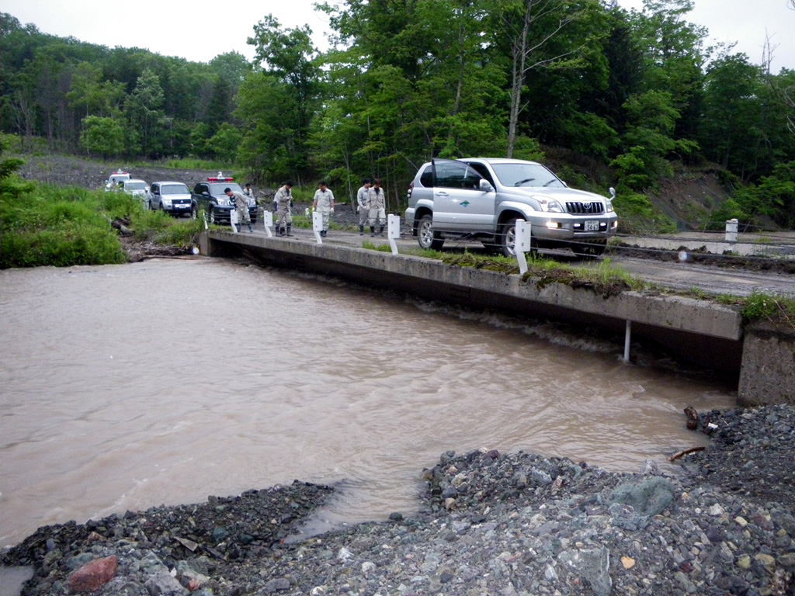
Fig. 1 An example of figures or photographs

Tab. 1 An example of table
Day/Month/Year | Place | Name of symposium
24-25/11/2005 | Hiroshima | International Symposium on Utilization of Disaster Information  -Organizing and Sharing Disaster Information in Asian Country-
15/10/2007 | Tokyo | Japan-Korea-Taiwan Symposium of Sediment-related Disasters  - The state-of-art of the research and measures of sediment-related disasters-
18-19/11/2009 | Tokyo | Asia-Pacific Symposium on New Technologies for Prediction and Mitigation of Sediment Disasters

Keywords : Asia-Pacific, sediment disasters, prediction, mitigation

